Pandas program

Aim
To create a Pandas DataFrame from a dictionary and display the first five rows, information about data types and non-null values, and the statistical summary of numerical data.
Algorithm
1. Import the Pandas library.
2. Create a dictionary containing the Name, Age, and City of three people.
3. Convert the dictionary into a Pandas DataFrame using pd.DataFrame(data).
4. Display the first five rows using df.head().
5. Display the DataFrame information using df.info(), including column names, data types, and non-null values.
6. Display the statistical summary of numerical columns using df.describe().
7. Observe the output.
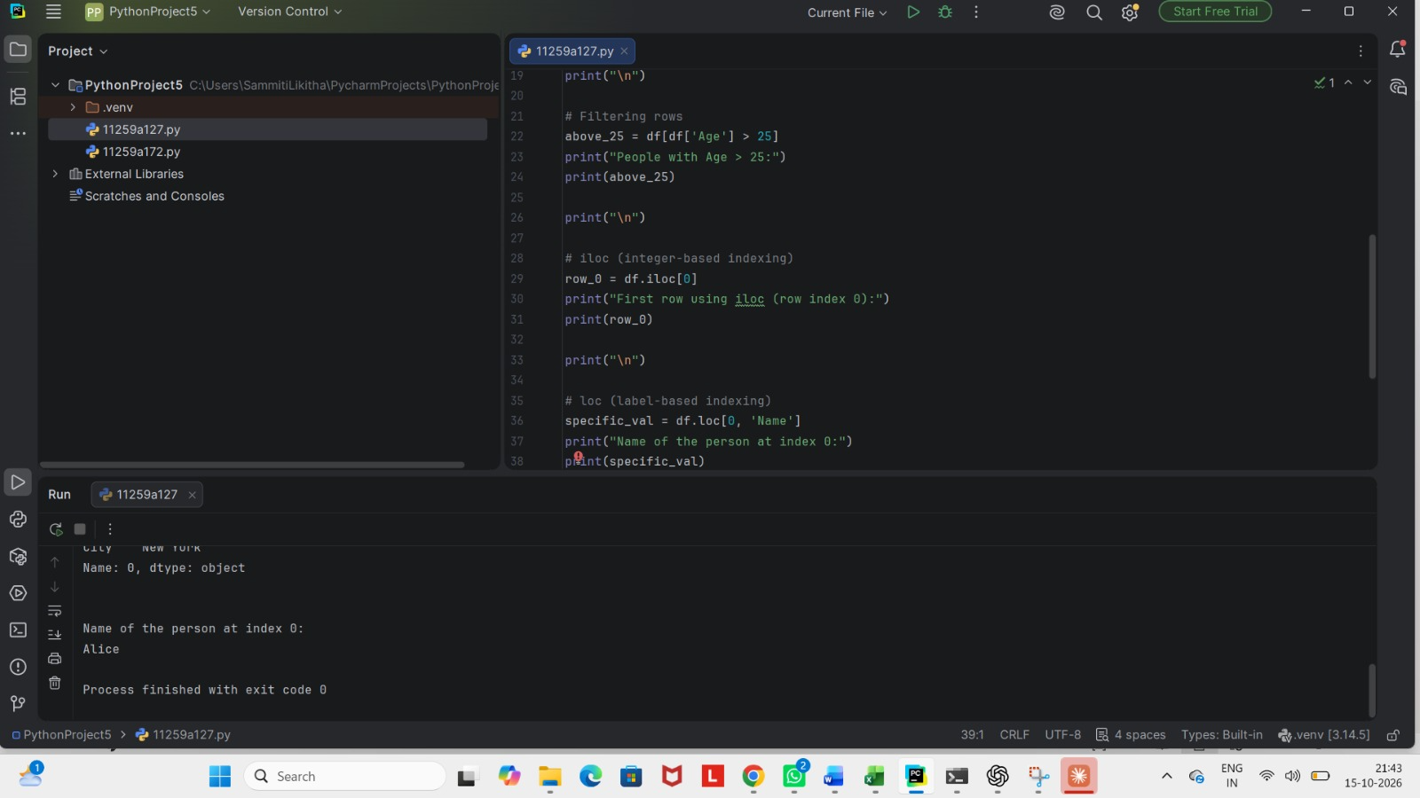
Result
The Pandas DataFrame was successfully created from the dictionary. The program displayed the first five rows, the structure and data types of the DataFrame, and the statistical summary of the numerical column (Age).

Aim
To perform data selection and filtering operations on a Pandas DataFrame using column selection, conditional filtering, iloc, and loc.
Algorithm
1. Select the Age column from the DataFrame using df['Age'].
2. Display the selected Age column.
3. Filter the rows where the age is greater than 25 using df[df['Age'] > 25].
4. Display the filtered rows.
5. Select the first row using integer-based indexing with df.iloc[0].
6. Display the first row.
7. Retrieve the Name value at index 0 using label-based indexing with df.loc[0, 'Name'].
8. Display the selected value.
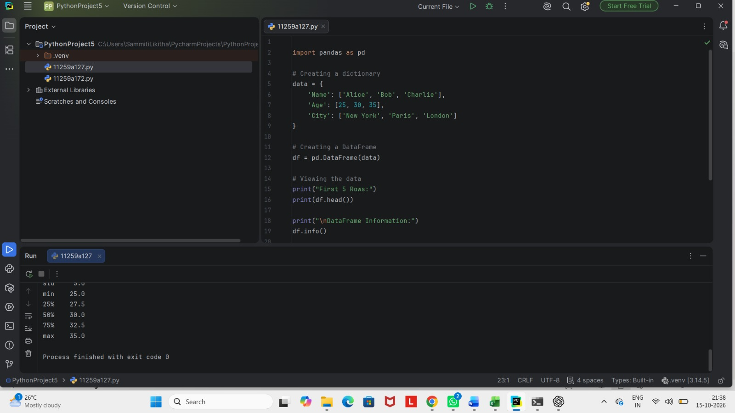
Result
The program successfully performed column selection, conditional row filtering, integer-based indexing using iloc, and label-based indexing using loc
Aim
To identify and handle missing values in a Pandas DataFrame using isnull(), dropna(), and fillna() methods, including replacing missing age values with the mean of the column.
Algorithm
1. Import the Pandas and NumPy libraries.
2. Create a sample dataset containing Name, Age, and City columns with some missing values represented by NaN.
3. Convert the dictionary into a Pandas DataFrame using pd.DataFrame(data).
4. Display the original DataFrame.
5. Identify and count missing values in each column using df.isnull().sum().
6. Remove rows containing missing values using df.dropna() and display the cleaned DataFrame.
7. Replace all missing values with 0 using df.fillna(0) and display the result.
8. Create a copy of the original DataFrame.
9. Calculate the mean of the Age column and replace missing age values with the mean using fillna().
10. Display the final DataFrame after filling missing age values.

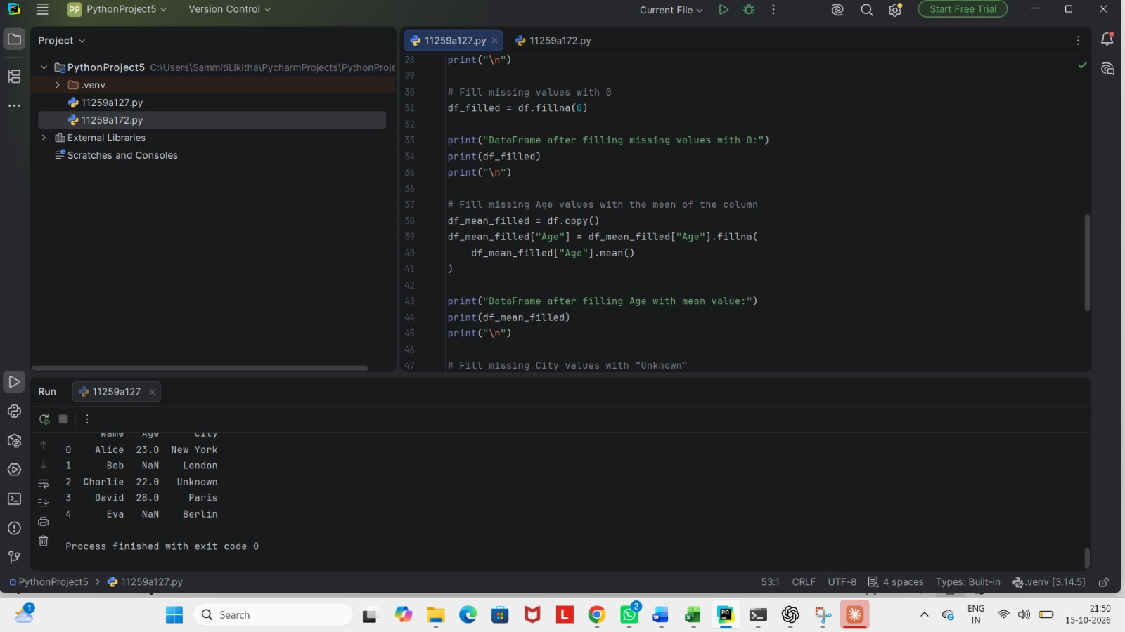

Result
The program successfully identified and counted missing values, removed rows containing missing values, replaced missing values with zero, and filled missing age values with the mean of the Age column.

